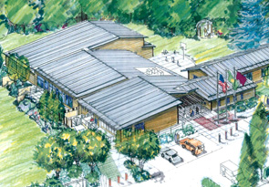
Application to Display or Present Art
In the Village Green Community Center
or on its Grounds

The Village Green Art Committee is a volunteer committee of the Village Green Community Center. The purpose of the Committee is to promote regional artists and encourage education and access to a diversity of artistic expression by the display or performance of art at the Village Green Community Center. Due to the limited display space in the Center we have established the following process for accepting, displaying or facilitating art works.
- Complete this application.
- The Art Committee will review applications.
- The Art Committee will notify applicants promptly following the Committee meeting when decisions have been made.
- Art displays will be rotated approximately every two months to maximize the number of art pieces and variety of art viewed by the public. Any artwork sold during the exhibit should remain on display until replaced.
- Artwork should be finished work appropriate for gallery display, i.e. framed or mounted to permit hanging as shown on page 3. Attaching directly to the wall (nails or tape) is not permitted.
- Artist takes responsibility for insuring work if needed.
- Suggested donation to Village Green Foundation for use of the Gallery is 10% of sales revenue.
The figure on page 3 shows available space. Please confirm that you have enough work to fill the minimum. If you would like to exhibit with another artist, please include their name (partner must also submit an application).
Please include a website/URL for images of your work or submit three hard-copy representative images of your work with this application form to the manager of the Village Green.

Name ______________________________________________________________________________
Address ____________________________________________________________________________
Phone __________________________ Email ______________________________________________
Submission Date _________________________
Website/URL (not required)_____________________________________________________________
I can fill the space. I would like to show with a partner. Name: __________________________
Description and medium of work:

Available Display Space:
Main Hall Left
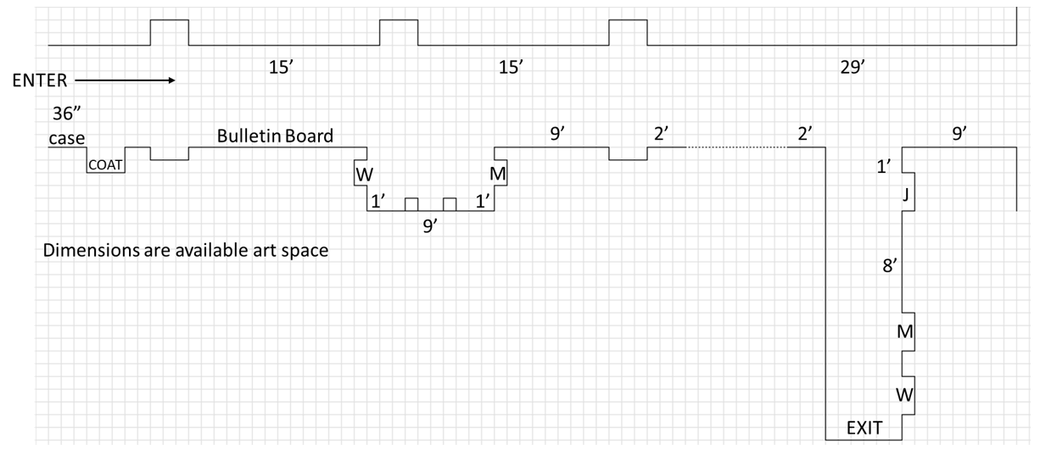
Main Hall Right
Secondary Hall
Restroom Alcove
Artist should plan to fill Main Hall Left at a minimum. The Art Committee would also prefer that Main Hall Right be filled. Secondary Hall and Restroom Alcove are available as well.

Hanging System:
